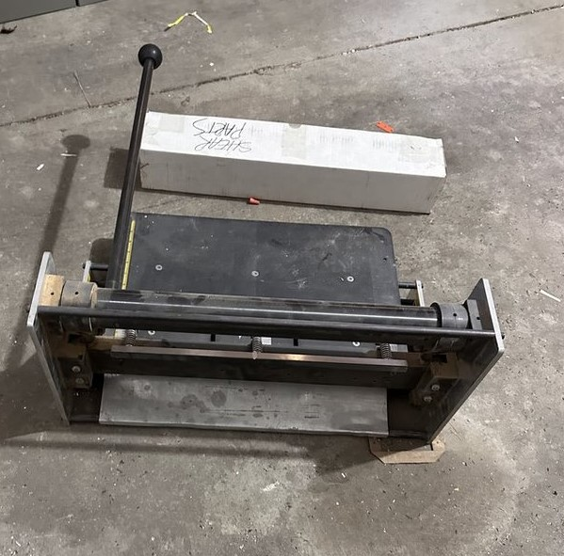
For Sale
Model 3001 Bench Shear
$300 Make me an offer, all offers considered!
Contact:
John E. Bollwinkel
John@acesignsutah.com
435-640-5418

